**Functional Baseline**

In this section, the concept ranging system is reverse engineered into a functional baseline document. The functional baseline will focus on the physical ranging system device. All functions of the system and their relationships are shown in the function flow block diagram (FFBD) below.

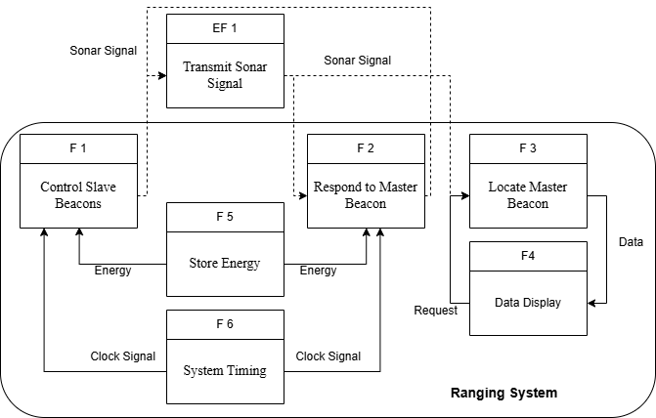

The second level of FFBD is shown below where F1 , F2 and F3 are further decomposed.Note that power inputs are required to all the functions in second level FFBD but they are omitted to make the demonstration concise.The decomposed functional flow presents the internal operations of the ranging system, specifically how sonar signals are generated, transmitted, received, processed, and converted into range data.

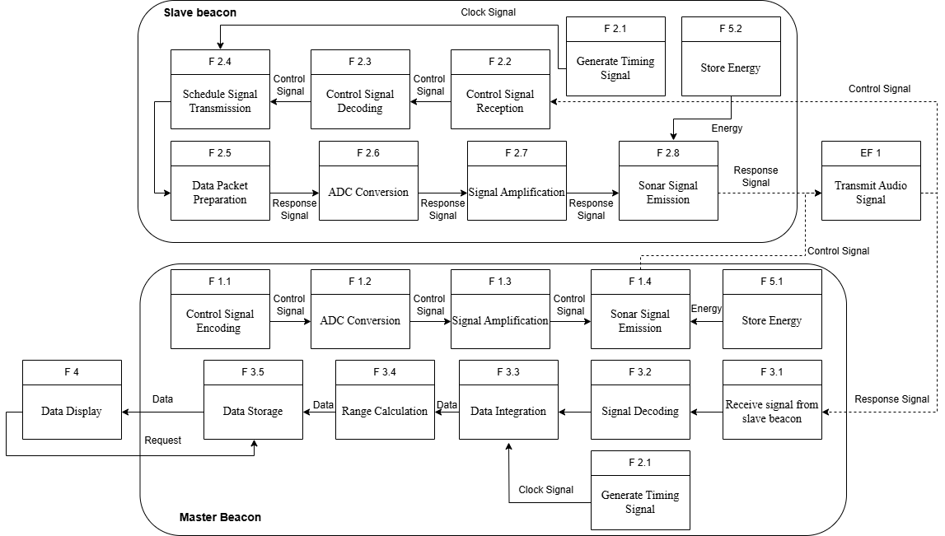

All the functions shown in the above figure are given in the following table.

|  |  |  |
| --- | --- | --- |
| Numbering | Functions | Description |
| F 1 | Control Slave Beacons | Coordinate and issue control signals to slave beacons, including activation timing and response scheduling |
| F 2 | Respond to Master Beacon | Slave beacon receives control commands from the master and transmits sonar response signals accordingly |
| F 3 | Locate Master Beacon | Master beacon collects sonar responses from slaves and computes relative position or distance data |
| F 4 | Data Display | |  | | --- | | Visually display the processed ranging data upon user request, such as distance or coordinates | |
| F 5 | Store Energy | Store electrical energy to power the ranging system components, ensuring continuous operation |
| F 6 | System Timing | Generate and maintain synchronized clock signals for controlling timing-sensitive tasks across beacons |
| F 1.1 | Control Signal Encoding | Convert system commands into encoded digital control signals to be transmitted to the slave beacon |
| F 1.2 | |  | | --- | | ADC Conversion  (Master) | | Convert analog signals from sensors or environment into digital signals for processing. |
| F 1.3 | Signal Amplification (Master) | Amplify digital or analog signals before transmission to ensure signal integrity. |
| F 1.4 | Sonar Signal Emission (Master) | Emit acoustic sonar pulses for ranging through a piezoelectric transducer. |
| F 2.1 | Generate Timing Signal (Master & Slave) | Generate internal clock signals to synchronize time-sensitive operations across beacons. |
| F 2.2 | Control Signal Reception | Receive and interpret encoded control signals from the master beacon. |
| F 2.3 | Control Signal Decoding | Decode received control signals to determine the appropriate operational response. |
| F 2.4 | Schedule Signal Transmission | Schedule when to respond to the master with sonar signals according to decoded commands. |
| F 2.5 | Data Packet Preparation | Format and prepare the response data packets for transmission back to the master. |
| F 2.6 | ADC Conversion (Slave) | Digitize received sonar signals into digital data for internal processing. |
| F 2.7 | Signal Amplification (Slave) | Boost weak analog sonar signals to a suitable level before ADC conversion. |
| F 2.8 | Sonar Signal Emission (Slave) | Transmit sonar response signals toward the master beacon via a transducer.. |
| F 3.1 | Receive Signal from Slave Beacon | Capture and buffer sonar response signals emitted by the slave beacon.. |
| F 3.2 | |  | | --- | | Signal Decoding  (Master) | | Decode signal packets from slave beacons to extract timing and control information. |
| F 3.3 | Data Integration | Integrate data from multiple slave beacons into a unified dataset. |
| F 3.4 | Range Calculation | Calculate the distance between master and slave beacons based on time-of-flight or signal delay. |
| F 3.5 | Data Storage | Store the processed ranging data for further display or analysis. |
| F 5.1 | Store Energy (Master) | Store electrical energy in batteries or capacitors to support continuous system operation. |
| F 5.2 | Store Energy (Slave) | Manage and store energy supply in slave beacons independently. |